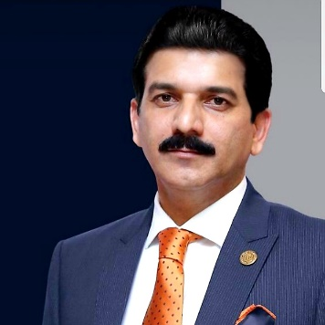

MUHAMMAD IJAZ

- Group Chief Executive - Topaz Group of Companies

An entrepreneur and a mastermind behind diversified thoughts, Mr. Muhammad Ijaz started off with his career in 2000 after completion of his MBA in Marketing & Total Management. Being self-driven and passionate, in a very short span of time he made his mark among the top-notch business elite. His quest for growth fostered his finesse to commence a 360-degree Advertising and Media group with name of Topaz Group of Companies and working with more than 30 Top Brands in the field of Out of Home, Creative, Print and Electronic Media. He has also diversified international experience in the field of Networking, PR, Trade, Media and Advertising.

